DIODES APPLICATIONS –INTRODUCTION

SEMICONDUCTORS
Semiconductors are materials which are used to manufacture all electronic and optoelectronic devices, computers components, IC’s (integrated circuits), mems (microelectromecahnical sytems) and even nanodevices (example quantum dot leds’ ) today. They are so widely used because of their special band gap and its related properties. They even differ from conductors and insulators in their electrical and optical properties because of their band gap (E_{g}) being different than that of conductors and insulators. Now band gap of a material is defined as the energy difference between conduction band and valence band in terms of electron energy. It is a major factor in deciding a material application for e.g. Conductors have no E_{g}, semiconductors have an E_{g} of the order of 1ev.
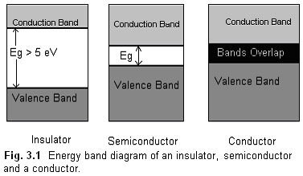
At room temperature, conductors have very high number of charge carriers in conduction band which gives high conductivity whereas for the case of insulators very few electrons reach the conduction band at room temperature. For semiconductors reasonable numbers of charge carriers reach the conduction band. Refer table 1.1. There is a direct relation between intrinsic charge carrier concentration (n_{i}) and conductivities (σ). Since Ge has three orders of n_{i} greater than that of Si therefore its conductivity (σ) is also 3 orders higher. It is to be noted that they are both good conductors at room temperature.
TABLE 3.1
 | Insulators | Semiconductor  Si Ge |  | Conductor
Band Gap  (ev) | > 5 ev | ~ 1.1 | ~ 0.6 | No band gap
Resistivity (ρ)  ( Ω cm ) | 10 ⁻¹² | 0.02 | 0,02 x 10 ⁻³ | 10 ⁶
n_{i} ( cm ⁻³ ) | --- | 1.5 x 10 ¹⁰ | 2.5 x 10 ¹³ | ~ 10 ²³
Temperature  coefficient of R | Positive | Positive | Positive | Negative

The resistance of conductors increases with increase in temperature because the lattice vibrations block the free flow of electrons on application of potential. For the case of intrinsic semiconductor the resistance decreases more electron hole pairs are generated because of breakage of bonds. With an addition of small amount of impurity (one in 10 ⁷ atoms) from third group or fifth group , the conductivity increases by an order of 10 ⁵ . This si because number of free charge carriers increases by 10 ⁵ times ( 10¹² / 10⁷ ).
DIODES : FABRICATION AND CONSTRUCTION: A diode is a two terminal device made by a P type and n type materials or between a semiconductor and a metal. If the junction is made between a metal and semiconductor then it is called a Schottky diode whose application is in rectifying and non-rectifying contacts and Schottky devices.
There are various methods of fabrication of a junction depending on the application of the diode.
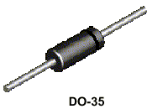

Table 3.2 gives selected a few techniques and applications.
S.N. | Fabrication Technique | Application
1 | Alloy Junction: A small dot of In is kept on n type Si and heated to 150ºC. It melts and dissolves. The temperature is then lowered. | High  PIV diode
2. | Point Contact: The junction area is kept very small so that the capacitance value is low. | High  Frequency (10Ghz)
3. | Epitaxial Growth: Junction is fabricated on an epitaxial layer. | Low  Resistance
4. | Grown Junction: Czochralski technique where a single semiconductor seed which is immersed in molten semiconductor material is gradually with drawn with the help of a rod which holds the seed. pn junction is fabricated by first adding p type and then n type impurity. | High current application because of high area of contact.

POTENTIAL BARRIER

When the pn junction is made, there is a transfer of charge through the junction region because of concentration gradient of the charge carriers, as shown in fig 1.2. This creates a barrier potential.) The direction of barrier potential is as shown by the arrow from n type to p type. It is the formation of potential barrier that makes the device useful since it can be controlled by various factors like biasing etc.
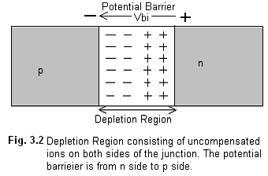

The direction of this field is from n side to p side as shown in figure 2. The equation of this field barrier (Vbi) is given by
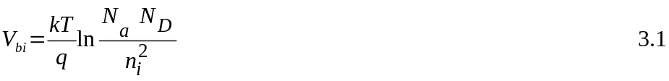
where N_{a} and N_{d} are the acceptor and donor concentrations, n_{i} is the intrinsic concentration, q is the electron charge and T is the temperature in absolute values. V_{bi}
is lesser for Ge ( 0.2 V ) than for Si (0.6 V ) since n_{i} is higher for Ge compared to Si.
If a voltage V is applied across the diode, the current flowing across it is given by the Shockley equation
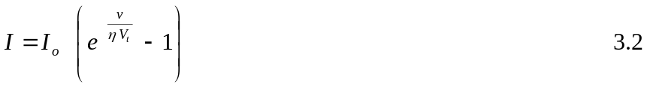
where V is the bias potential across the diode. The factor η is 1 for Si and 2 for Ge diodes. V_{t} is volt equivalent of temperature and is given by 11,600 / T. Its value at room temperature is 26 mV. I_{o} is the reverse saturation current in mA which depends upon temperature and doping. This is called reverse saturation since its value cannot be increased by increasing Vr.

BIASING
Forward Biasing: If an external voltage is applied such that negative of battery is connected to n side and positive to the p side then V_{bi} will get reduced and more current can flow across the junction. Reverse Bias On the other hand if an external voltage is applied in the reverse direction i.e. positive of battery to n side and negative of battery to p side then the barrier potential increases and only minority charge carriers flow across the junction. Thus the current is very small in microamperes and is independent of the external voltage, up to a certain voltage. Beyond this voltage, the diode breaks down by either Avalanche breakdown mechanism or Zener breakdown mechanism.
PEAK INVERSE VOLTAGE (PIV):
PIV is the maximum reverse bias voltage which can be applied safely to a diode without its breaking down. Beyond this voltage a diode breaks down.
Avalanche Breakdown The minority carriers which are diffusing across the junction get sufficient energy from the increased voltage to break the covalent bonds and generate more Electron hole pairs. These generated pairs break more bonds and this process is multiplicative. Thus at the breakdown condition the current suddenly shoots up because of additional extra pairs.

ZENER breakdown This is applicable only to heavily doped junctions which have a very narrow depletion layer. On increase of reverse voltage the electric field increases so much that the covalent bonds break and generate minority carriers which constitute the reverse current.

MULTIMETER TEST OF DIODES
One can know whether a specific terminal of a diode is n or p by measuring the resistance with multimeter. To do so keep the multimeters in resistance mode connect its positive lead to the anode of diode and negative lead to its cathode. During the test ,the multimeter passes current through the diode and the diode gets forward biased. It thus indicated very low resistance of the order of 100 Ω . If the leads are now reversed than the diode gets reverse biased and offers very high resistance of the order of MΩ. This can be read in the multimeter again. If a diode reads very low resistance in the forward as well as reverse bias then it is fused. On the other hand if it reads high resistance in the forward as well as reverse bias then it is open.
Table 3.1 gives the comparison of Si and Ge diodes in terms of band gap (E_{g}) V_{bi} and, PIV
TABLE 3.1.
Diode  Material | E_{g}  (ev) | V_{bi}  (V) | PIV  (V)
Ge Diode | 0.785 | 0.2 | 400
Si Diode | 1.21 | 0.6 | 1000

It is clear that Si diodes have an advantage over Ge diodes since their band gap is more and they have a higher PIV. If the band gap is more they are more impervious to temperature changes since there is a direct relation between Eg and working temperature. But Ge diodes are more useful for switching circuits since their Vbi is almost 0 V.
Table1.2 gives the specifications of some commonly used diodes.
TABLE 3.2 (edit to data sheet at end)
Device Number | Material used. | I_{F} (mA) | V_{F}(V) | V_{BR}  (V) | Power Rating (mW)
OA91 | Ge | 50 | 2.1 | 115
In 4148 | Si | 100 | 1.0 | 75
In 4149 | Si | 100 | 1.0 | 75
IN 4007 | Si | 1000 | 1.6 | 1000
IN463 |  | 1.0 | 1.0 | 200
IN462 |  | 5.0 | 1.0 | 70
IN459A |  | 100.0 | 1.0 | 200
T151 |  | 200.0 | 1.0 | 20
BZX 88 series | zener
BZX85  series | zener

